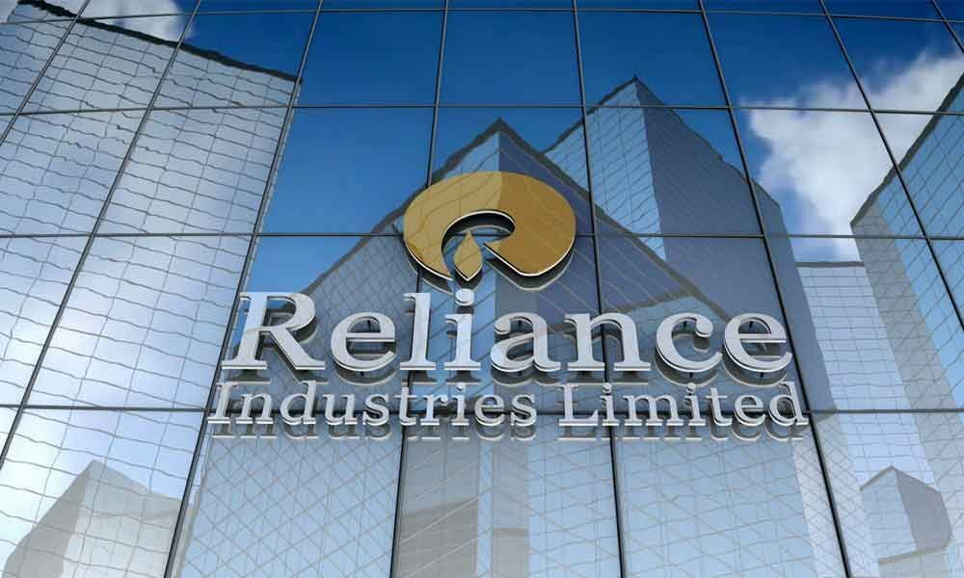STOCK PERFORMANCE ANALYSIS

* GENERAL OVERIEW:

Reliance Industry Limited (RIL) is an Indian multinational conglomerate

company headquartered in Mumbai, India. Founded by Dhirubhai Ambani in 1966, it has grown to become one of the largest and most profitable companies in India.

RIL operates in various sectors including petrochemicals, refining, oil & gas exploration, retail, telecommunications, media, and digital services. Its subsidiaries and divisions include Reliance Retail, Reliance Jio Infocom Limited (telecommunications), Reliance Petroleum, Reliance Life Sciences, and Reliance Industrial Infrastructure Limited, among others.

* GLOBAL PRESENCE:

Reliance Industries Limited (RIL) has a notable global presence across various sectors, leveraging its diversified portfolio of businesses .250 companies under Reliance Empire

* KEY BUSINESSES:

1.Petrochemicals and Refining: RIL is a major player in the global petrochemicals and refining industry. Its refinery at Jamnagar is one of the largest and most sophisticated in the world, enabling it to compete globally in the refining sector.

2.Telecommunications: While Reliance Jio primarily operates in India, it has been expanding its footprint in other countries as well it has been exploring opportunities to enter new markets with its telecommunications services.

3. Retail: Reliance Retail has been eyeing international expansion in the retail sector. It has expressed interest in entering markets outside of India to leverage its expertise in retail operations and capitalize on growing consumer markets.

4. Oil & Gas Exploration: While RIL's oil and gas exploration activities are primarily focused in India, it has also ventured into international markets through strategic partnerships and acquisitions. It has explored opportunities countries such as the United States, Canada, and East Africa.

* Financial Performance:

Reliance Industries has been a dominant force in the Indian business landscape, driven by its strong financial performance, strategic investments, and diversification across multiple sectors. However, for the most up-to-date information on RIL's financial performance, I would recommend checking recent financial reports and updates from reliable sources.

* Leadership:

As of my last update in January 2022, Mukesh Ambani serves as the Chairman and Managing Director of Reliance Industries Limited (RIL). He has been instrumental in leading the company to become one of India's largest and most profitable conglomerates.

Apart from Mukesh Ambani, there are several key executives and leaders. They are Nita Ambani, Akash Ambani and Isha Ambani, Ajay Singh, Darshan Mehta, PMS Prasad.

They all worked hard & also guiding the company's strategic direction and ensuring its continued growth and success in various business sectors.

* Corporate Responsibilities:

Reliance Industries Limited (RIL), sustainability is viewed as an environmental and social responsibility, which allows the organisation to deliver on stakeholder expectations. RIL continues to communicate its obligations and performance to all stakeholders through its Business Responsibility Report (BRR).

* Regulatory Environment:

The regulatory environment for Reliance Industries Limited, a conglomerate in India, is governed by various regulatory bodies such as the Securities and Exchange Board of India (SEBI), the Competition Commission of India (CCI), and the Ministry of Corporate Affairs (MCA), among other.

* Historical Data:

|  |  |
| --- | --- |
| Previous Close | **2,969.55** |
| Open | **2,968.00** |
| Bid | **0.00 x 0** |
| Ask | **0.00 x 0** |
| Day's Range | **2,950.00 - 2,988.00** |
| 52 Week Range | **2,130.79 - 3,024.90** |
| Volume | **4,454,167** |
| Avg. Volume | **6,072,021** |
| Market Cap | **20.122T** |
| Beta (5Y Monthly) | **0.60** |
| PE Ratio (TTM) | **28.61** |
| EPS (TTM) | **103.93** |
| Earnings Date | **Apr 19, 2024 - Apr 23, 2024** |
| Forward Dividend & Yield | **9.00 (0.30%)** |
| Ex-Dividend Date | **Aug 21, 2023** |
| 1y Target Est | **2,272.10** |

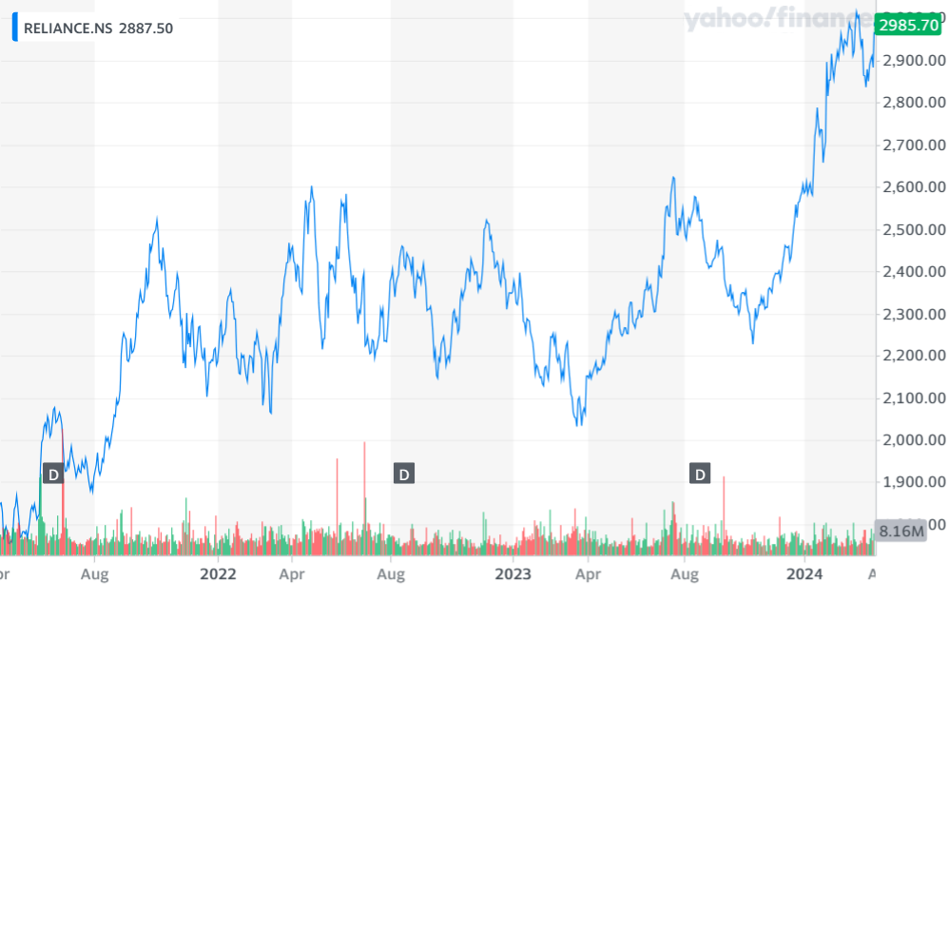

Historical Stock Price Data Chart

* Key Matrices:

Key metrics of Reliance Industries Limited (RIL) can vary depending on the specific industry segment or business division being analysed. However, here are some commonly tracked key metrics that provide insights into the company's financial performance, operational efficiency, and market position.

1.Revenue: TOTAL income generated by Reliance Industries from its various business operations, including revenue from sales of products, services, and other sources.

2. EBITDA (Earnings Before Interest, Taxes, Depreciation, and Amortization): A measure of operating performance that reflects earnings before accounting for non-operating expenses and non-cash items such as depreciation and amortization.

3. Return on Equity (ROE): A measure of profitability that indicates how much profit a company generates with the shareholders' equity invested in the business.

Also ; Debt-to-Equity Ratio, Free Cash Flow (FCF), Market Capitalization, Gross Margin, Customer Metrics, etc.., These key metrics provide investors, analysts, and stakeholders with valuable insights into Reliance Industries' financial health, operational efficiency, profitability, and market performance across its diverse business segments.

|  |
| --- |
| Year Average Stock Price Year Open Year High Year Low Year Close Annual % change  2024 2855.70 2,883.70 2,839.65 2,855,60 4.52M 10.47%  2023 2884.30 2,871.85 2,899.00 2,858.50 4.56M 11.58% |

Historical Annual Stock Price Data

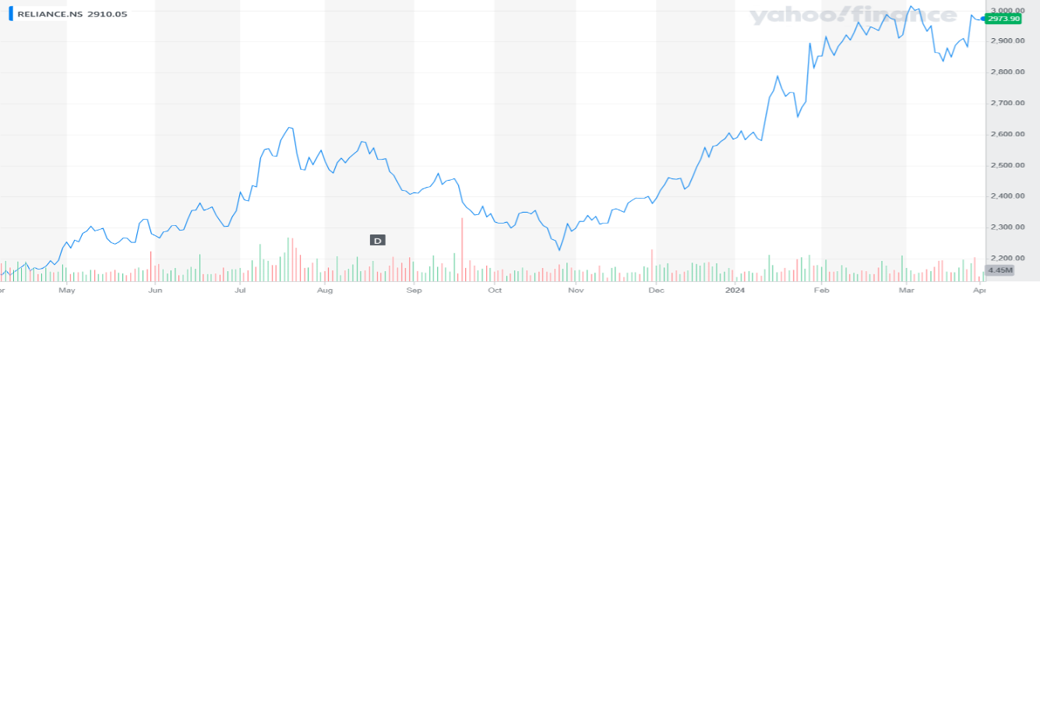

STOCK PRICE CHANGE CHART

VOLATILITY

The volatility of Reliance Industries Limited (RIL) can be assessed by analysing its historical price movements. Volatility refers to the degree of variation in the price of a stock over a specific period. Here's how you can evaluate the volatility of Reliance Limited:

•Standard Deviation: One common measure of volatility is the standard deviation of stock returns. A higher standard deviation indicates higher volatility. By calculating the standard deviation of RIL's historical stock returns over various periods (e.g., daily, weekly, monthly), you can gauge the level of volatility experienced by the stock.

•Beta: Beta measures the sensitivity of a stock's returns to market movements. A beta greater than 1 indicates that the stock tends to be more volatile than the overall market, while a beta less than 1 suggests lower volatility. Reliance's beta can be compared to the market benchmark (such as the Nifty 50 or BSE Sensex) to assess its relative volatility.

•Historical Price Charts: Visual inspection of historical price charts can provide insights into the volatility of Reliance Limited. Wide price fluctuations, large price gaps, and frequent changes in direction indicate higher volatility.

•Volatility Index (VIX): The India VIX, also known as the fear gauge, measures the market's expectation of volatility over the next 30 days. Monitoring the VIX can provide an indication of overall market volatility, which may impact individual stocks like Reliance Limited.

•News and Events: Significant news events, earnings announcements, regulatory developments, or macroeconomic factors can impact the volatility of Reliance Limited. Monitoring news flow and assessing its impact on stock price movements can help understand short-term fluctuations in volatility.

It's essential to analyse volatility in conjunction with other factors such as fundamental analysis, market sentiment, and company-specific developments to gain a comprehensive understanding of Reliance Limited's stock behaviour. Additionally, investors should consider their risk tolerance and investment objectives when interpreting volatility metrics.

STOCK COMPARISON AND ANALYSIS



Versus

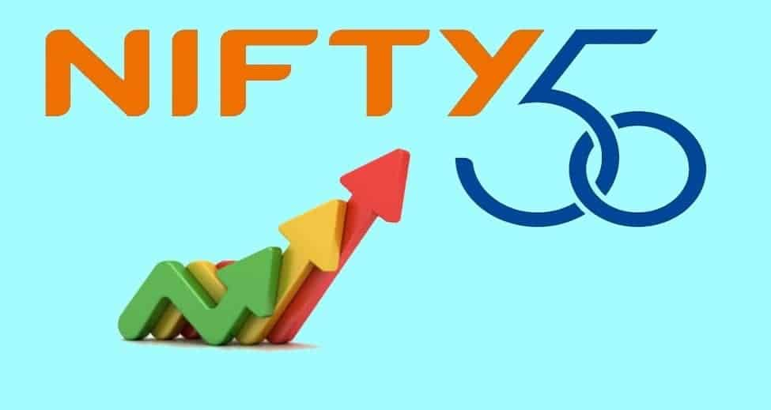

PRICE INFORMATION

|  |
| --- |
|  |
| Exchange | NYSE | NASDAQ |  | |
| Open | 331.85 | 57.23 |
| High | 334.57 | 57.29 |
| Low | 328.83 | 56.89 |
| Last | 333.08 | 57.01 |
| Change | -0.06 | -0.19 |
| % Change | -0.02% | -0.33% |
| Volume | 267,900 | 62,900 |
| 20-Day Average Volume | 266,445 | 31,945 |
| Previous Close | 333.14 | 57.20 |
| Industry | Mining - Misc | N/A |
| Has Options | Yes | Yes |
|  | | | |

PERFORMANCE

|  |
| --- |
| **5-Days** |
| %Chg. | +0.47% since 03/25/24 | +1.89% since 03/25/24 |
| Low | 328.83 on 04/02/24 | 55.92 on 03/27/24 |  |  |
| High | 337.11 on 03/27/24 | 57.46 on 04/01/24 |  |  |
| **1-Month** |
| %Chg | +4.03% since 03/01/24 | -0.58% since 03/01/24 |  |  |
| Low | 312.83 on 03/11/24 | 55.34 on 03/19/24 |  |  |
| High | 337.11 on 03/27/24 | 58.25 on 03/08/24 |  |  |
| **3-Month** |
| %Chg | +18.35% since 01/02/24 | +4.97% since 01/02/24 |  |  |
| Low | 273.88 on 01/05/24 | 53.37 on 01/23/24 |  |  |
| High | 337.11 on 03/27/24 | 58.25 on 03/08/24 |  |  |

KEY STATISTICS

Market Capitalization, $K 19,130,562 190,984

Shares Outstanding, K 57,425 3,350

Annual Sales 14,805,900,000 0

Annual Net Income 1,335,900,000 0

Last Quarter Sales 3,337,300,000 N/A

Last Quarter Net Income 272,700,000 N/A

60-Month Beta 0.87 0.72

KEY EVENTS:

Reliance Industries Limited (RIL) has been involved in numerous key events throughout its history that have shaped its growth and trajectory. Here are some notable events:

1. Foundation and Initial Growth (1960s-1980s): Founded by Dhirubhai Ambani in 1966 as a textile manufacturer, Reliance quickly expanded into other sectors, including petrochemicals, refining, and telecommunications.

2. Diversification into Petrochemicals (1980s-1990s): Reliance emerged as a major player in the petrochemicals industry with the commissioning of its first integrated petrochemical complex at Hazira, Gujarat, in 1991. This marked the beginning of its dominance in the Indian petrochemicals market.

3. Entry into Oil Refining (1990s): Reliance ventured into oil refining with the establishment of the Jamnagar Refinery, the world's largest grassroots refinery complex, in the late 1990s.

This significantly boosted its refining capacity and positioned it as a global player in the refining industry.

4. Launch of Reliance Jio (2016): Reliance Jio Infocom Limited (Jio), a subsidiary of RIL, disrupted the Indian telecommunications market with the launch of its high-speed 4G network in September 2016. Jio's entry led to a significant reduction in data tariffs, widespread adoption of digital services, and increased competition among telecom operators.

5. Expansion into Retail: Reliance Retail, the retail arm of RIL, has witnessed rapid expansion and consolidation in recent years. Through acquisitions,

partnerships, and organic growth, Reliance Retail has become one of the largest and most diversified retail chains in India, spanning multiple formats including supermarkets, hypermarkets, convenience stores, and e-commerce platforms.

6. Vision for Green Energy: In 2020, Mukesh Ambani, Chairman and Managing Director of RIL, announced the company's ambitious plan to become a net-zero carbon emitter by 2035. This includes investments in renewable energy, electric vehicles, and other sustainable initiatives, reflecting RIL's commitment to environmental stewardship and green growth.

These events represent significant milestones in Reliance Industries Limited's journey, highlighting its evolution from a textile manufacturer to a diversified conglomerate with interests spanning petrochemicals, refining, telecommunications, retail, and green energy.

THANK YOU

BY

K. Sudha Madhavi

ANDRA UNIVERSITY